**SUBSCRIBERS GALORE: EXPLORING WORLD’S TOP YOUTUBE CHANNELS**

**INTRODUCATION:**

**Tableau is a powerful tool used for data analysis and visualization.it allows the creation of amazing and interactive visualization and that too without coding.**

**Tableau is a visual analytics platform that is revolutionizing the way we use data to solve problems by enabling individuals and organisation to make the most of their data.**

**It enables users to build various charts, graphs, maps, dashboard ,and stories for visualizing and analysing data in order to aid in business choices.**

**PROBLEM DEFINITION & DESIGN THINKING:**

**EMPATHY MAP:**

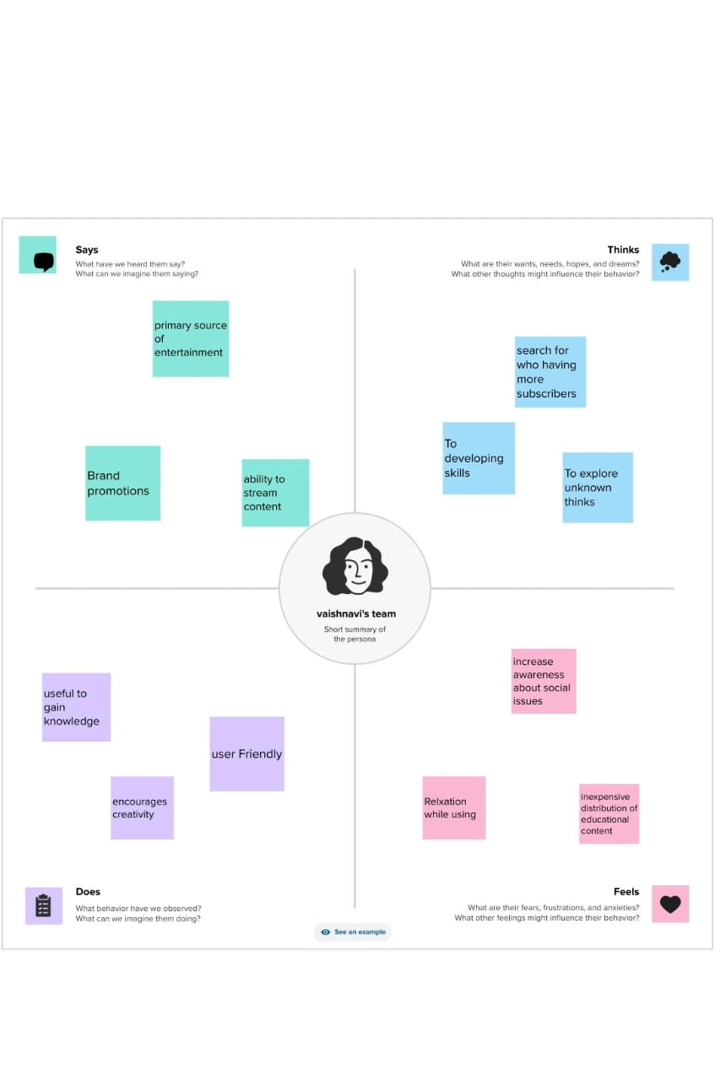

**BRAINSTORMING MAP:**

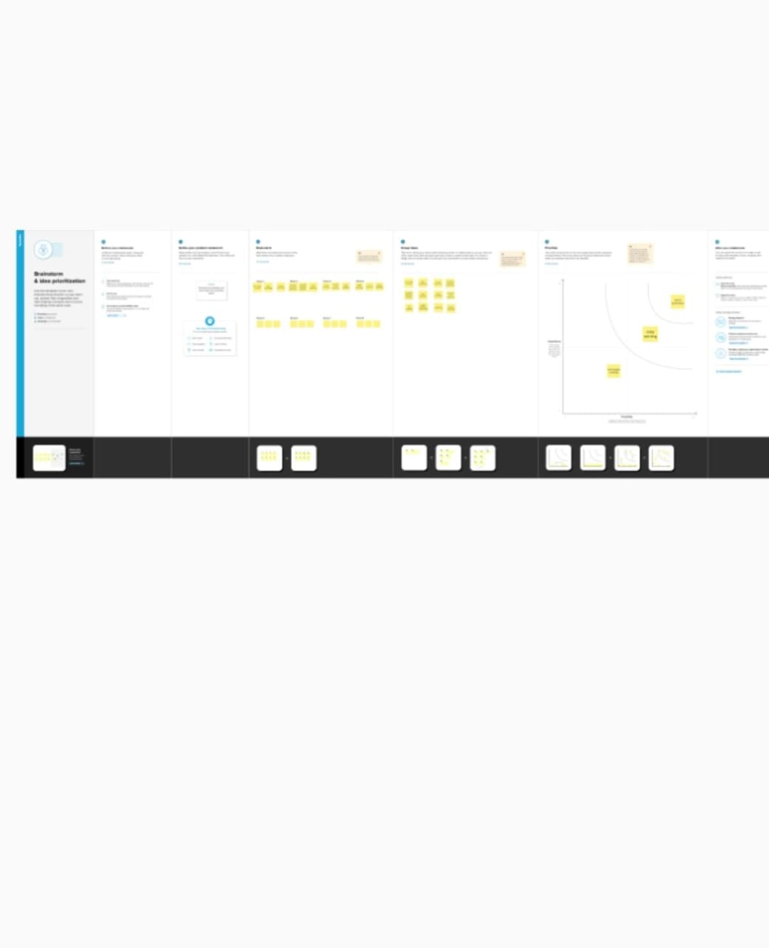

**RESULT:**

**Youtube subscriber more in india than countries .**

**More subscribers for music channel in youtube.**

**ADVANTAGES AND DISADVANTAGES:**

***ADVANTAGES:***

* ***Used for brand promotion***
* ***Primary source of entertainment***
* ***Increase awareness about social awareness***
* ***To developing skills***

**DISADVANTAGES:**

* **ADS a drawback of youtube for the audience.**
* **A lots of distraction.**
* **Obscenity –one of the biggest drawbacks that youtube.**
* **Defamation and bullying.**

***APPLICATION:***

**We use youtube to share a free video in website that makes it easy tp watch online videos.**

***CONCLUSION:***

**Youtube is very useful platform to study and develop our knowledge .if we use youtube in right way we become shine.**

***FUTURE SCOPE:***

**Youtube will be the world’s most popular entertainment platform. As more people use it and continue to innovate, this platform will create more wealth and have more creativity than any other entertainment platform in the world . the youtube platform will become a destination for immensive programming.**

***APPENDIX:***